Adjustment: 3/27/2017

Male Nose adjustment: please move nose position down as shown.

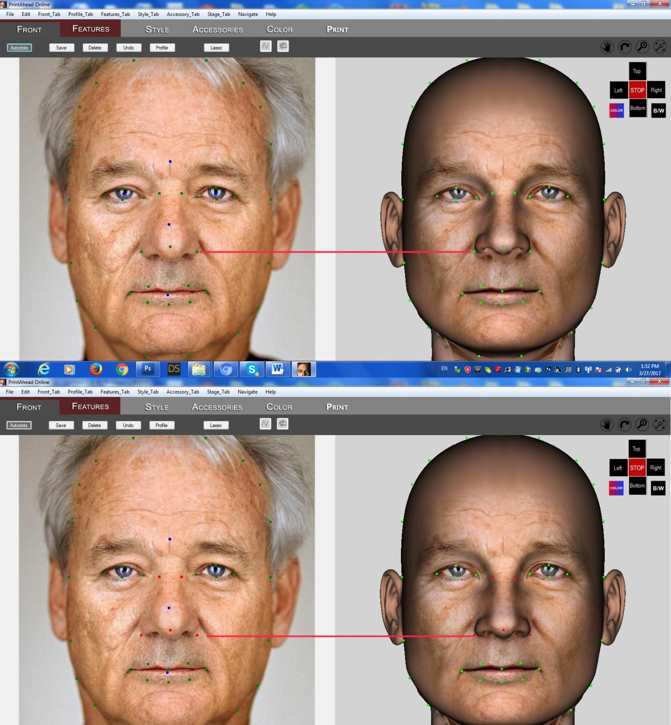

Child adjustment:

Current condition: Green arc is too low on forehead

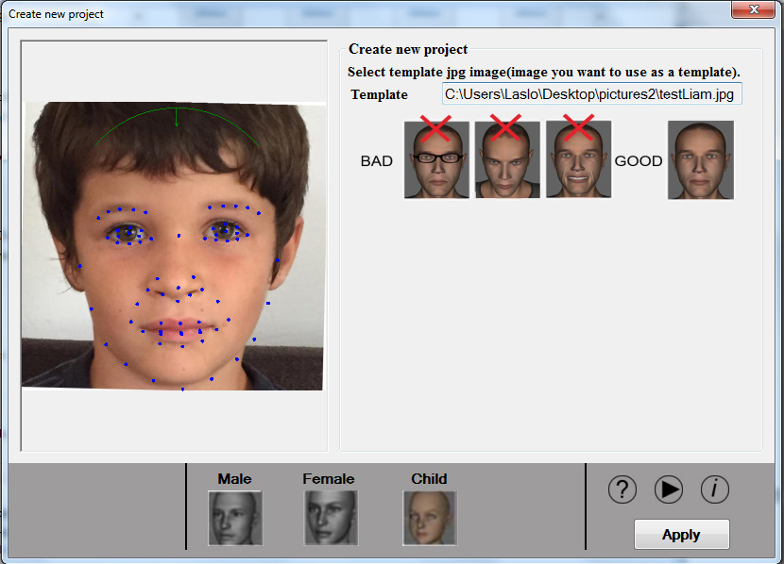

Desired condition: When “Child” button is pushed, move the green arc that it is the same distance from mid-point as the distance to chin.

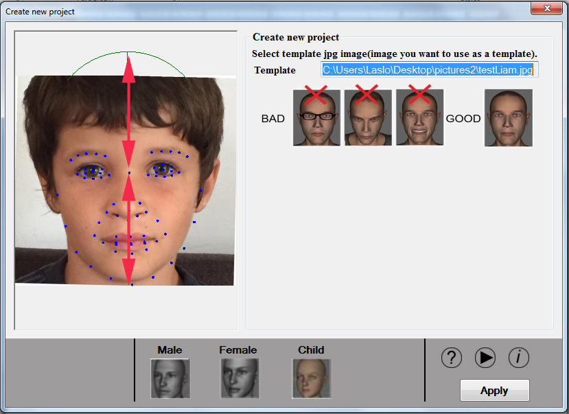

Child adjustment 2: When green arc is moved up, head gets narrowly elongated

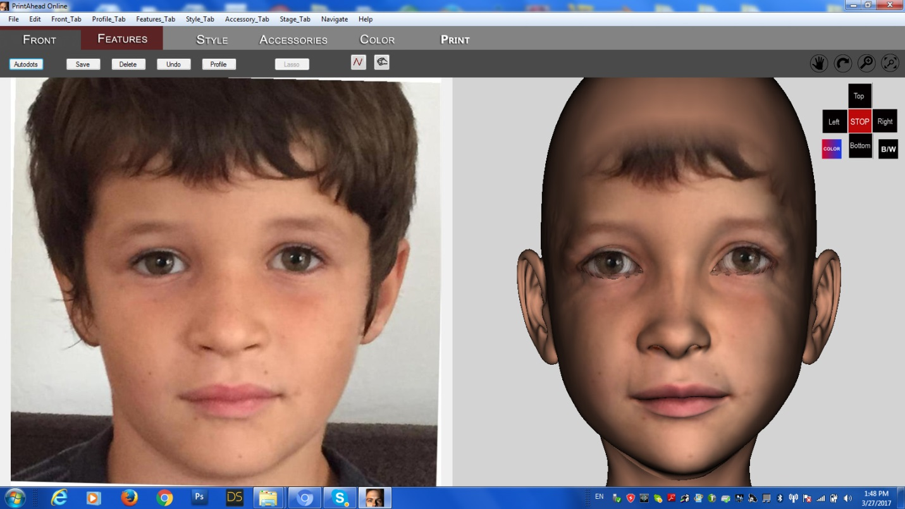

Therefore: non-Luxand dots need to be moved wider as shown

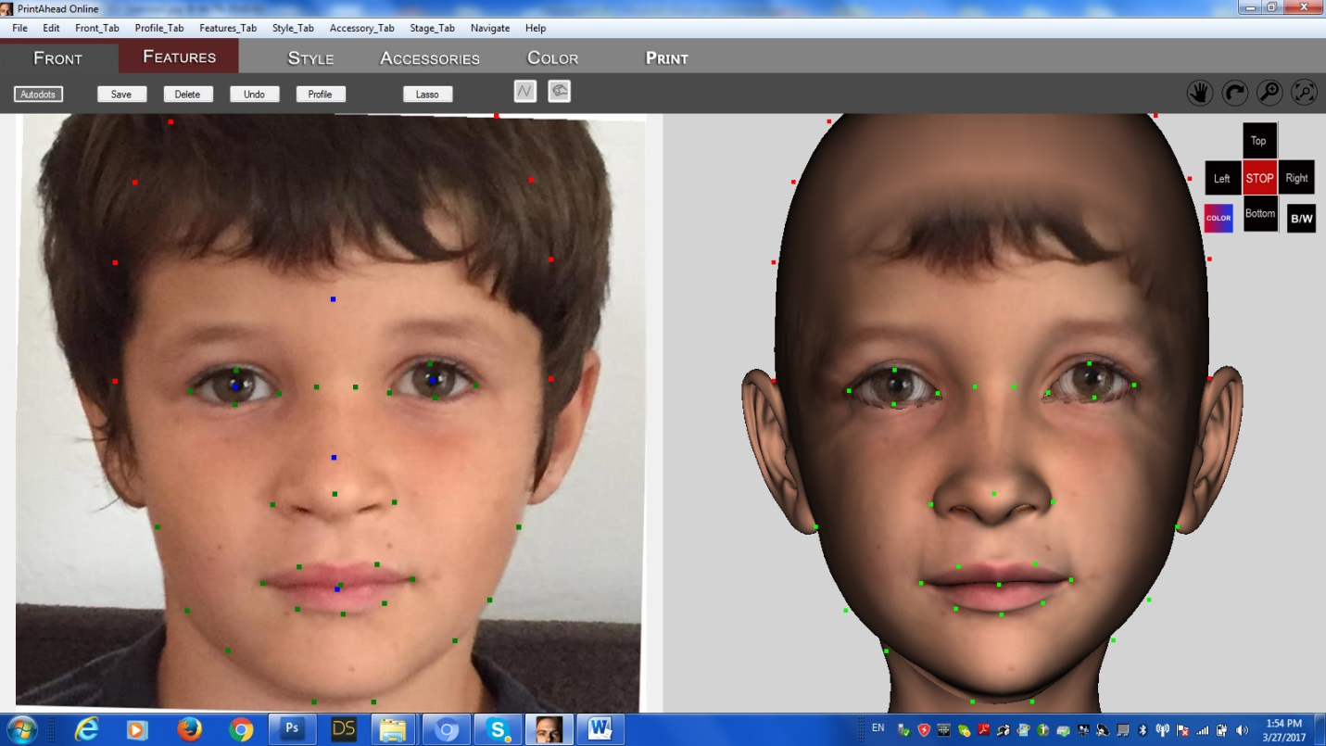

Eye problem: Outside dots of the eye need to be moved further back. Current condition

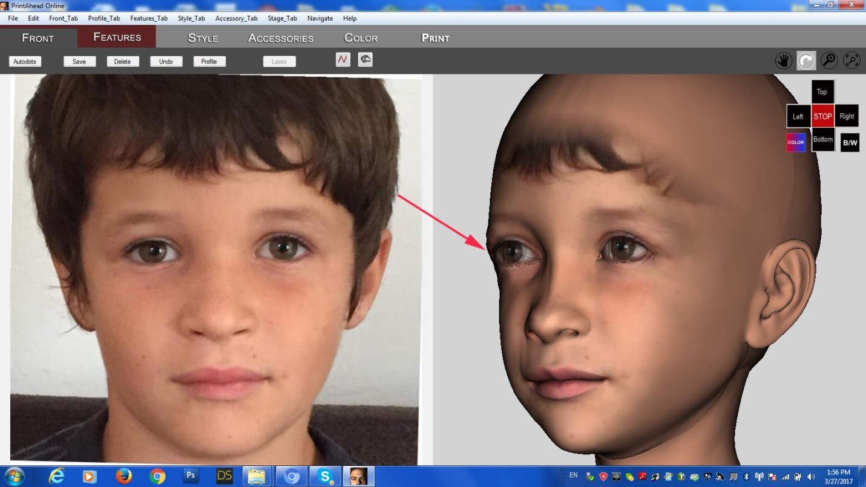

Desired condition

